______________________________________________________________

UM-SJTU JOINT INSTITUTE

PHYSICS LABORATORY

(VP 241)

______________________________________________________________

LABORATORY REPORT

EXERCISE 2

THE HALL PROBE: CHARACTERISTICS AND APPLICATIONS

|  |  |  |
| --- | --- | --- |
| **Name: Weikai Zhou** | **ID: 518021911039** | **Group: 8** |
| Name: Yingtao Zou | ID: 518370910069 | Group: 8 |
|  |  |  |
| Date: 6 December 2019 |  |  |

1. **Introduction [1]**
   1. **Objectives**

* Try to study the principle of the Hall effect and its applications by using a Hall probe.
* Try to verify that the Hall voltage is proportional to the magnetic field
* Try to study the sensitivity of an integrated Hall probe by calculating the magnetic field at the center of a solenoid.
* Try to measure the magnetic field distribution along the axis of the solenoid and compare it with the corresponding theoretical curve.
  1. **Theoretical background**

The phenomenon that when an electric current passes through a sample placed in a magnetic field, electric potential difference proportional to the current and to the magnetic field appears across the material in the direction perpendicular to both the current and the magnetic field is observed by E.H. Hall in 1879. This effect is known as the Hall effect, and since its discovery it has led to many practical applications. The principle of the Hall effect is used in devices for magnetic field measurements as well as in position and motion detectors.

* + 1. **Hall effect**

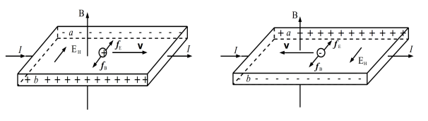If we consider a conducting sheet, which is made of a metal or a semiconductor, placed in a magnetic field so that the plane of the sheet is perpendicular to the direction of the magnetic field **B** (Figure 1). An electric potential difference between the sides *a* and *b* of the sheet will be generated, if the electric current *I* passes through the sheet in the direction as shown in Figure 1. We call this phenomenon as the Hall effect, and the electric potential difference is called the Hall voltage .

Figure 1. The principle of the Hall effect

From a microscopical perspective, the Hall effect is caused by the Lorentz force, which is a force acting on charges moving in a magnetic field. The Lorentz force leads to the deflection of the moving charges. These charges accumulate on one side of the sheet and increase the magnitude of the transverse electric field (the Hall field). There will be an electric force acting upon the charges due to this field. A balance will be eventually reached and will stabilize since and act in opposite direction. The sign of the charge carriers (positive or negative) will determine the sign of . Therefore, we can analyze the sign of to determine the type of charge carriers in semiconductors.

The Hall voltage is proportional to both the current and the magnitude of the magnetic field, and inversely proportional to the thickness of the sheet *d* if the external magnetic field is not too strong

where is the so-called Hall coefficient and , where is the so-called sensitivity of the Hall element.

* + 1. **Integrated hall probe**

If we measure Hall voltage with a Hall probe when the sensitivity and the current *I* are fixed, we can easily find the magnitude of the magnetic field. We should amplify the Hall voltage before the measurement since it is usually very small.

Silicon can be used to design both the Hall probe and the integrated circuits, so it is convenient to arrange the Hall probe and the electric circuits into a single device. And we usually call such a device an integrated Hall probe.

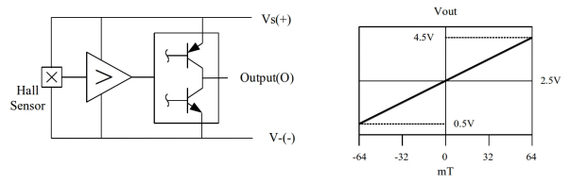The integrated Hall probe SS495A consists of a Hall sensor, an amplifier, and a voltage compensator (Figure 2). We can read the output voltage ignoring the residual voltage. The working voltage , and the output voltage is approximately when the magnetic field is zero. The relation between the output voltage and the magnetic field is

Figure 2. The integrated Hall probe SS495A (left). The relation between the

output voltage U and the magnitude of the magnetic field B (right).

* + 1. **Magnetic field distribution inside a solenoid**

We use the following formula to calculate the magnetic field distribution on the axis of a single layer solenoid

where is the number of turns of the solenoid, is its length, is the current through the solenoid wire, and is the solenoid’s diameter. The magnetic permeability of vacuum is .

We use the solenoid with ten layers for this experiment. The magnetic field for each layer can be calculated using Eq. (3). We can add contributions of all layers to find the net magnetic on the axis of the solenoid. The theoretical value of the magnetic field inside the solenoid with is given in Table 1.

|  |  |  |  |
| --- | --- | --- | --- |
|  |  |  |  |
|  | 1.4366 |  | 1.4057 |
|  | 1.4363 |  | 1.3856 |
|  | 1.4356 |  | 1.3478 |
|  | 1.4343 |  | 1.2685 |
|  | 1.4323 |  | 1.1963 |
|  | 1.4292 |  | 1.0863 |
|  | 1.4245 |  | 0.9261 |
|  | 1.4173 |  | 0.7233 |

Table 1. Theoretical value of the magnetic field inside the solenoid

* + 1. **Study of the geomagnetic field with a Hall probe (optional)**

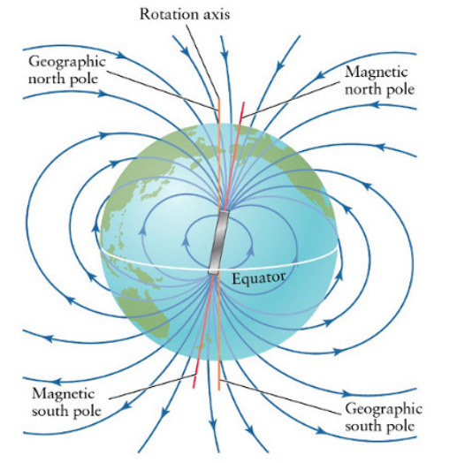The geomagnetic field is the magnetic associated with the Earth. The geomagnetic field lines are shown schematically in Figure 3. The Earth’s magnetic field is similar to that of a bar magnet tilted about 11.5 degrees from the spin axis of the Earth.

Figure 3. Magnetic field of the Earth

The figure below (Figure 4) shows the geomagnetic field distribution of China in 1970. We can see that the magnetic inclination is about 44.5and the magnitude of the magnetic field in Shanghai is about 48000 nT.

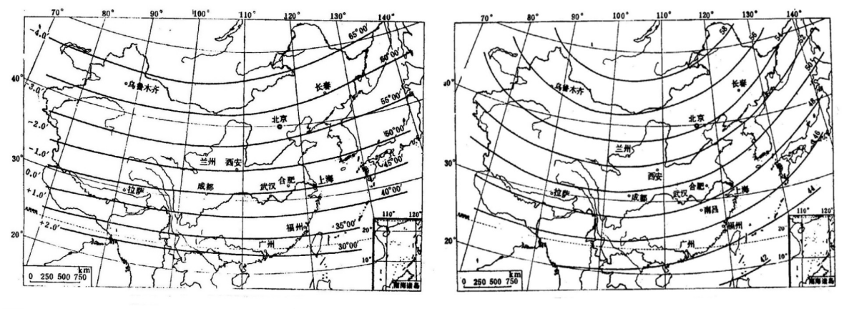Figure 4. Geomagnetic inclination in China, 1970 (left). The

magnitude of the geomagnetic field in China, 1970 (right).

1. **Apparatus [1]**
   1. **Experimental setup**

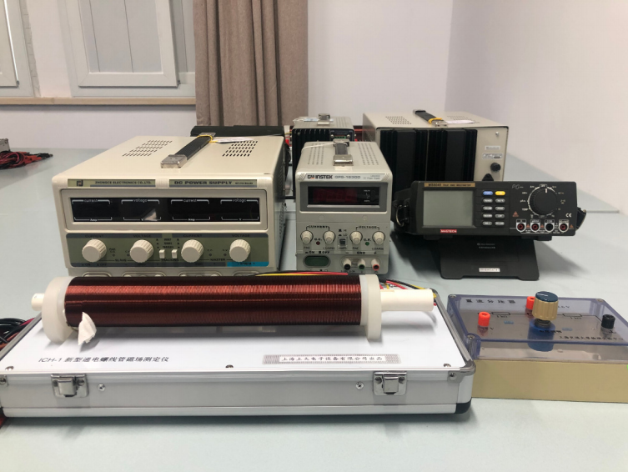The experimental setup shown in Figure 5 consists of an integrated Hall probe SS495A (Figure 6) with (at the working voltage 5 V) or , a solenoid, a power supply, a voltmeter, a DC voltage divider, and a set of connecting wires.

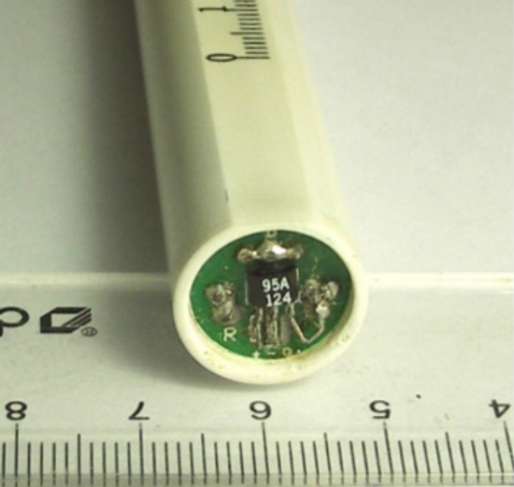Figure 5. Measurement setup

Figure 6. Integrated Hall probe SS495A

* 1. **Precision or uncertainty**

|  |  |
| --- | --- |
|  |  |
|  |  |
|  |  |
|  |  |

Table 2. precision or uncertainty

1. **Measurement procedure [1]**
   1. **Relation between sensitivity and working voltage** 
      1. We place the integrated Hall probe at the center of the solenoid. Then, we set the working voltage at 5 V and measure the output voltage ( = 0) and ( = 250 mA). We take the theoretical value of *B* (*x* = 0) from Table 1 and calculate the sensitivity of the probe by using Eq. (2).
      2. Then, we measure for different values of (form 2.8 V to 10 V). We should calculate and plot the curve vs. .
   2. **Relation between output voltage and magnetic field** 
      1. We should connect the 2.4~2.6 V output terminal of the DC voltage divider and the negative port to the voltmeter with , . then, we should adjust the voltage until .
      2. We should place the integrated Hall probe at the center of the solenoid and measure the output voltage *U* for different values of ranging from 0 to 500 mA, with intervals of 50 mA.
      3. We should explain the relation between *B* (*x* = 0) and the Hall voltage . We should pay attention to the fact that the output voltage *U* is the amplified signal from . The theoretical value of *B* (*x* = 0) can be found from Table 1.
      4. We should plot the curve *U* vs. *B* and find the sensitivity by a linear fit (use a computer). We should compare the value we obtained with the theoretical value in given in the Apparatus section and the value we have found in the first part.
   3. **Magnetic field distribution inside the solenoid**
      1. We should measure the magnetic field distribution along the axis of the solenoid for = 250 mA, record the output voltage *U* and the corresponding position *x*. Then we should find *B* = *B*(*x*). (We can use the value of found in the previous part of the experiment).
      2. We should use a computer to plot the theoretical and the experimental curve showing the magnetic field distribution inside the solenoid. We should use dots for the data measured and a solid line for the theoretical curve. The origin of the plot should be at the center of the solenoid.
   4. **Measurement of the geomagnetic field (optional)**
      1. We should use the integrated Hall probe to measure the magnitude and the direction of the geomagnetic field.
   5. **Cautions** 
      1. We should make sure that the V + port and the V − port of the integrated Hall probe are connected correctly, otherwise the probe will get damaged.
      2. After turning the power supply on, we should wait for 5 minutes before starting measurements, in order to let the power supply temperature reaches a steady state.
      3. Working voltage must be lower than 10 V for measurements described in part 3.1..
      4. We should set the output voltage and the current to zero before turning off the power supply.
      5. We should turn off the power supply before disassembling the equipment.
2. **Results**
   1. **Relation between sensitivity and working voltage**

The data we get are listed below (Table 3&4).

|  |  |  |
| --- | --- | --- |
|  | ( = 0) [V]  [V] | ( = 250 mA) [V]  [V] |
| 5.00 | 2.513 | 2.634 |

Table 3. Data for and with

|  |  |  |  |
| --- | --- | --- | --- |
|  |  | ( = 0) [V]  [V] | ( = 250 mA) [V]  [V] |
| 1 | 2.80 | 1.3970 | 1.4677 |
| 2 | 3.20 | 1.5983 | 1.6796 |
| 3 | 3.60 | 1.8050 | 1.8964 |
| 4 | 4.00 | 2.0053 | 2.1061 |
| 5 | 4.40 | 2.2103 | 2.317 |
| 6 | 4.80 | 2.410 | 2.525 |
| 7 | 5.20 | 2.614 | 2.738 |
| 8 | 5.60 | 2.815 | 2.942 |
| 9 | 6.00 | 3.013 | 3.148 |
| 10 | 6.40 | 3.213 | 3.350 |
| 11 | 6.80 | 3.406 | 3.546 |
| 12 | 7.20 | 3.601 | 3.745 |
| 13 | 7.60 | 3.791 | 3.936 |
| 14 | 8.00 | 3.980 | 4.127 |
| 15 | 8.40 | 4.167 | 4.312 |
| 16 | 8.80 | 4.355 | 4.501 |
| 17 | 9.40 | 4.632 | 4.784 |
| 18 | 10.00 | 4.915 | 5.066 |

Table 4. Data for and with different

From Table 1, we can get that the theoretical value of with . While in our experiment, , we can calculate *B* in this part as follows

* + 1. **Data for and with**

For the data recorded in Table 3, we can use Eq. (2) to get that

with relative uncertainty as . Although it is larger than 5%, we may still think this part is relatively successful because it is still within 10%. The reasons may be the precision of the device. For example, the unit of is [A] when we adjust it on the device, while the unity required is [mA], which will increase error. If we can use better device, the result will be better. Besides, we only measure the data for once. If we measure more times, it will be better.

* + 1. **Data for and with different**

Using the first measurement as an example, we can calculate as follows

The whole table is listed below for the answer of the rest calculation (Table 5).

|  |  |  |  |  |  |  |
| --- | --- | --- | --- | --- | --- | --- |
|  | [V] | [V] | [V/T] | [V/T] | [] | [] |
| 1 | 2.80 | 0.014 | 19.7 | 0.7 | 7.0 | 0.2 |
| 2 | 3.20 | 0.016 | 22.6 | 0.7 | 7.1 | 0.2 |
| 3 | 3.60 | 0.018 | 25.4 | 0.8 | 7.1 | 0.2 |
| 4 | 4.00 | 0.02 | 28.1 | 0.9 | 7.0 | 0.2 |
| 5 | 4.40 | 0.02 | 30 | 2 | 6.8 | 0.5 |
| 6 | 4.80 | 0.02 | 32 | 3 | 6.7 | 0.6 |
| 7 | 5.20 | 0.03 | 35 | 3 | 6.6 | 0.6 |
| 8 | 5.60 | 0.03 | 35 | 3 | 6.3 | 0.5 |
| 9 | 6.00 | 0.03 | 38 | 3 | 6.3 | 0.5 |
| 10 | 6.40 | 0.03 | 38 | 3 | 6.0 | 0.5 |
| 11 | 6.80 | 0.03 | 39 | 3 | 5.7 | 0.5 |
| 12 | 7.20 | 0.04 | 40 | 3 | 5.6 | 0.4 |
| 13 | 7.60 | 0.04 | 40 | 3 | 5.3 | 0.4 |
| 14 | 8.00 | 0.04 | 41 | 3 | 5.1 | 0.4 |
| 15 | 8.40 | 0.04 | 40 | 3 | 4.8 | 0.4 |
| 16 | 8.80 | 0.04 | 41 | 3 | 4.6 | 0.4 |
| 17 | 9.40 | 0.05 | 42 | 3 | 4.5 | 0.4 |
| 18 | 10.00 | 0.05 | 42 | 3 | 4.2 | 0.3 |

Table 5. Uncertainty for and

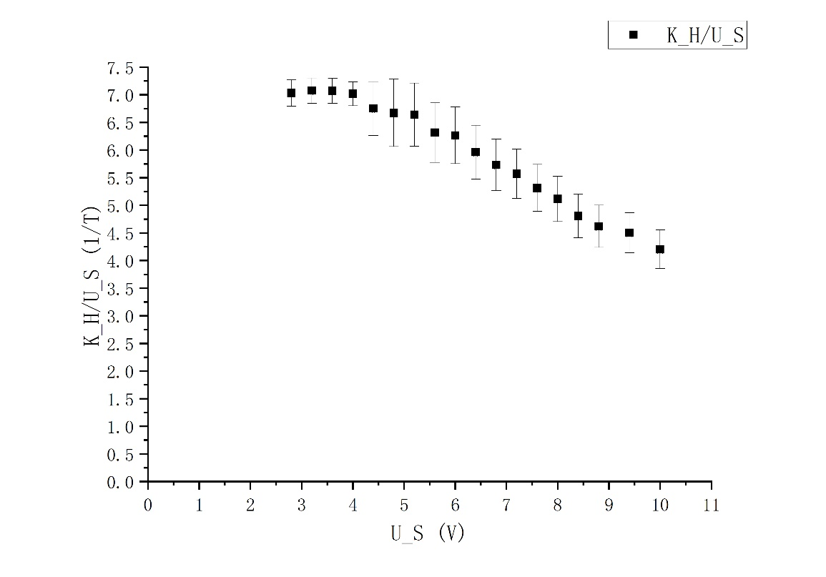Then, based on this table, we can plot the curve for vs. with origin (Figure 7).

Figure 7. vs.

Theoretically, should be proportional to , which means the graph we get should be like a horizontal line. In this figure, we can find that it tends to decline. The reasons for this may be due to the internal resistance of the wire or the precision of the device. But generally speaking, it still maintains in some range, which can prove that should be proportional to .

* 1. **Relation between output voltage and magnetic field**

The data we get are listed below (Table 6).

|  |  |  |
| --- | --- | --- |
|  |  | [V] |
| 1 | 0 | 0.00 |
| 2 | 50 | 27.35 |
| 3 | 100 | 49.86 |
| 4 | 150 | 73.21 |
| 5 | 200 | 98.44 |
| 6 | 250 | 119.66 |
| 7 | 300 | 143.82 |
| 8 | 350 | 165.28 |
| 9 | 400 | 186.52 |
| 10 | 450 | 209.82 |
| 11 | 500 | 233.4 |

Table 6. Measurement data for the vs. relation

Using the second measurement as an example, we can calculate the magnetic field as follows

The whole table is listed below for the answer of the rest calculation (Table 7).

|  |  |  |  |  |  |  |
| --- | --- | --- | --- | --- | --- | --- |
|  |  |  |  |  |  |  |
| 1 | 0 | 0 | 0.00000 | 0.0006 | 0 | 0 |
| 2 | 0.050 | 0.0010 | 0.02735 | 0.0006 | 0.000718 | 0.000014 |
| 3 | 0.100 | 0.002 | 0.04986 | 0.0006 | 0.00144 | 0.00003 |
| 4 | 0.150 | 0.003 | 0.07321 | 0.0006 | 0.00215 | 0.00004 |
| 5 | 0.200 | 0.004 | 0.09844 | 0.0006 | 0.00287 | 0.00006 |
| 6 | 0.250 | 0.005 | 0.11966 | 0.0007 | 0.00359 | 0.00007 |
| 7 | 0.300 | 0.006 | 0.14382 | 0.0007 | 0.00431 | 0.00009 |
| 8 | 0.350 | 0.007 | 0.16528 | 0.0007 | 0.00503 | 0.00010 |
| 9 | 0.400 | 0.008 | 0.18652 | 0.0007 | 0.00575 | 0.00011 |
| 10 | 0.450 | 0.009 | 0.20982 | 0.0007 | 0.00646 | 0.00013 |
| 11 | 0.500 | 0.010 | 0.2334 | 0.0007 | 0.00718 | 0.00014 |

Table 7. Calculated uncertainty for , and

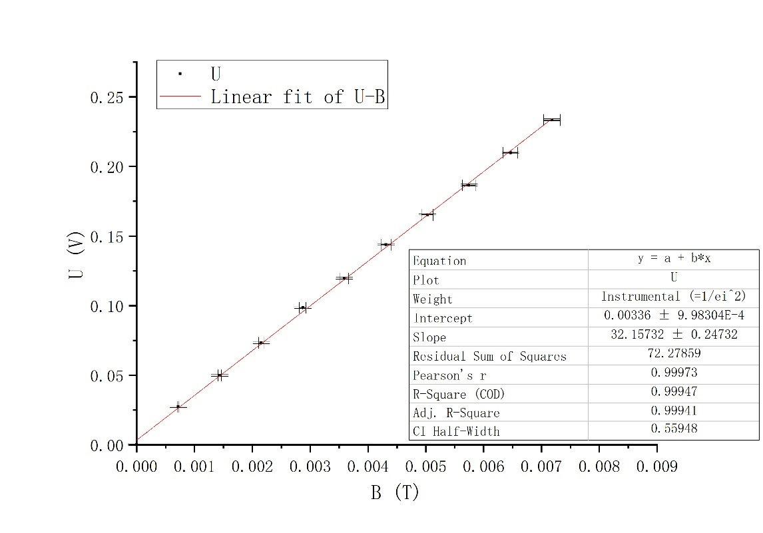 Based on this table, we can plot the relation of *U* vs. *B* with Origin (Figure 8).

Figure 8. Linear fit of *U* vs. *B*

Form this figure, we know that *U* and *B* are linearly dependent since and Pearson’s r = 0.99973, which are close to 1. And , where and .

Therefore, we can get that

Theoretically, , and the value we get in the previous part is . So, we can calculate the relative error respectively as

We can see that the relative error is small, so we may assume that this part is quite successful.

* 1. **Magnetic field distribution inside the solenoid**

The data we get are listed below (Table 8).

|  |  |  |  |  |  |
| --- | --- | --- | --- | --- | --- |
|  | *x* [cm] | [V] |  | *x* [cm] | [V] |
| 1 | 0.00 | 10.91 | 27 | 17.00 | 119.62 |
| 2 | 0.50 | 14.04 | 28 | 18.00 | 119.59 |
| 3 | 1.00 | 19.27 | 29 | 19.00 | 119.31 |
| 4 | 1.50 | 26.75 | 30 | 20.00 | 119.29 |
| 5 | 2.00 | 38.60 | 31 | 21.00 | 119.05 |
| 6 | 2.50 | 53.68 | 32 | 22.00 | 118.36 |
| 7 | 3.00 | 70.97 | 33 | 23.00 | 117.63 |
| 8 | 3.50 | 85.49 | 34 | 24.00 | 116.15 |
| 9 | 4.00 | 96.32 | 35 | 25.00 | 114.10 |
| 10 | 4.50 | 103.43 | 36 | 25.50 | 112.51 |
| 11 | 5.00 | 107.81 | 37 | 26.00 | 110.44 |
| 12 | 0.25 | 12.33 | 38 | 26.50 | 106.80 |
| 13 | 0.75 | 16.49 | 39 | 27.00 | 101.31 |
| 14 | 1.25 | 22.74 | 40 | 27.50 | 93.87 |
| 15 | 1.75 | 30.81 | 41 | 27.75 | 88.43 |
| 16 | 6.00 | 113.23 | 42 | 28.00 | 81.80 |
| 17 | 7.00 | 115.77 | 43 | 28.25 | 72.80 |
| 18 | 8.00 | 117.29 | 44 | 28.50 | 66.13 |
| 19 | 9.00 | 118.12 | 45 | 28.75 | 56.73 |
| 20 | 10.00 | 118.80 | 46 | 29.00 | 47.58 |
| 21 | 11.00 | 119.18 | 47 | 29.25 | 40.91 |
| 22 | 12.00 | 119.31 | 48 | 29.50 | 34.29 |
| 23 | 13.00 | 119.43 | 49 | 29.75 | 29.03 |
| 24 | 14.00 | 119.30 | 50 | 30.00 | 24.11 |
| 25 | 15.00 | 119.50 | 51 | 2.25 | 46.49 |
| 26 | 16.00 | 119.71 | 52 | 2.75 | 62.37 |

Table 8. Data for the *U* vs. *x* relation

Using the first measurement as an example, we can calculate that

The whole table is listed below for the answer of the rest calculation (Table 9).

|  |  |  |  |  |  |  |
| --- | --- | --- | --- | --- | --- | --- |
|  | *x* [cm] | [cm] |  | [V] | *B* [T] | [T] |
| 1 | 0.00 | 0.05 | 0.01091 | 0.0006 | 0.00034 | 0.00002 |
| 2 | 0.50 | 0.05 | 0.01404 | 0.0006 | 0.00044 | 0.00002 |
| 3 | 1.00 | 0.05 | 0.01927 | 0.0006 | 0.00060 | 0.00002 |
| 4 | 1.50 | 0.05 | 0.02675 | 0.0006 | 0.00083 | 0.00002 |
| 5 | 2.00 | 0.05 | 0.03860 | 0.0006 | 0.00120 | 0.00003 |
| 6 | 2.50 | 0.05 | 0.05368 | 0.0006 | 0.00167 | 0.00004 |
| 7 | 3.00 | 0.05 | 0.07097 | 0.0006 | 0.00220 | 0.00005 |
| 8 | 3.50 | 0.05 | 0.08549 | 0.0006 | 0.00265 | 0.00005 |
| 9 | 4.00 | 0.05 | 0.09632 | 0.0006 | 0.00299 | 0.00006 |
| 10 | 4.50 | 0.05 | 0.10343 | 0.0007 | 0.00321 | 0.00006 |
| 11 | 5.00 | 0.05 | 0.10781 | 0.0007 | 0.00335 | 0.00007 |
| 12 | 0.25 | 0.05 | 0.01233 | 0.0006 | 0.00038 | 0.00002 |
| 13 | 0.75 | 0.05 | 0.01649 | 0.0006 | 0.00051 | 0.00002 |
| 14 | 1.25 | 0.05 | 0.02274 | 0.0006 | 0.00071 | 0.00002 |
| 15 | 1.75 | 0.05 | 0.03081 | 0.0006 | 0.00096 | 0.00003 |
| 16 | 6.00 | 0.05 | 0.11323 | 0.0007 | 0.00352 | 0.00007 |
| 17 | 7.00 | 0.05 | 0.11577 | 0.0007 | 0.00360 | 0.00007 |
| 18 | 8.00 | 0.05 | 0.11729 | 0.0007 | 0.00364 | 0.00007 |
| 19 | 9.00 | 0.05 | 0.11812 | 0.0007 | 0.00367 | 0.00007 |
| 20 | 10.00 | 0.05 | 0.11880 | 0.0007 | 0.00369 | 0.00007 |
| 21 | 11.00 | 0.05 | 0.11918 | 0.0007 | 0.00370 | 0.00007 |
| 22 | 12.00 | 0.05 | 0.11931 | 0.0007 | 0.00371 | 0.00007 |
| 23 | 13.00 | 0.05 | 0.11943 | 0.0007 | 0.00371 | 0.00007 |
| 24 | 14.00 | 0.05 | 0.11930 | 0.0007 | 0.00370 | 0.00007 |
| 25 | 15.00 | 0.05 | 0.11950 | 0.0007 | 0.00371 | 0.00007 |
| 26 | 16.00 | 0.05 | 0.11971 | 0.0007 | 0.00372 | 0.00007 |
| 27 | 17.00 | 0.05 | 0.11962 | 0.0007 | 0.00371 | 0.00007 |
| 28 | 18.00 | 0.05 | 0.11959 | 0.0007 | 0.00371 | 0.00007 |
| 29 | 19.00 | 0.05 | 0.11931 | 0.0007 | 0.00371 | 0.00007 |
| 30 | 20.00 | 0.05 | 0.11929 | 0.0007 | 0.00370 | 0.00007 |
| 31 | 21.00 | 0.05 | 0.11905 | 0.0007 | 0.00370 | 0.00007 |
| 32 | 22.00 | 0.05 | 0.11836 | 0.0007 | 0.00368 | 0.00007 |
| 33 | 23.00 | 0.05 | 0.11763 | 0.0007 | 0.00365 | 0.00007 |
| 34 | 24.00 | 0.05 | 0.11615 | 0.0007 | 0.00361 | 0.00007 |
| 35 | 25.00 | 0.05 | 0.11410 | 0.0007 | 0.00354 | 0.00007 |
| 36 | 25.50 | 0.05 | 0.11251 | 0.0007 | 0.00349 | 0.00007 |
| 37 | 26.00 | 0.05 | 0.11044 | 0.0007 | 0.00343 | 0.00007 |
| 38 | 26.50 | 0.05 | 0.10680 | 0.0007 | 0.00332 | 0.00007 |
| 39 | 27.00 | 0.05 | 0.10131 | 0.0007 | 0.00315 | 0.00006 |
| 40 | 27.50 | 0.05 | 0.09387 | 0.0006 | 0.00292 | 0.00006 |
| 41 | 27.75 | 0.05 | 0.08843 | 0.0006 | 0.00275 | 0.00005 |
| 42 | 28.00 | 0.05 | 0.08180 | 0.0006 | 0.00254 | 0.00005 |
| 43 | 28.25 | 0.05 | 0.07280 | 0.0006 | 0.00226 | 0.00005 |
| 44 | 28.50 | 0.05 | 0.06613 | 0.0006 | 0.00205 | 0.00004 |
| 45 | 28.75 | 0.05 | 0.05673 | 0.0006 | 0.00176 | 0.00004 |
| 46 | 29.00 | 0.05 | 0.04758 | 0.0006 | 0.00148 | 0.00003 |
| 47 | 29.25 | 0.05 | 0.04091 | 0.0006 | 0.00127 | 0.00003 |
| 48 | 29.50 | 0.05 | 0.03429 | 0.0006 | 0.00106 | 0.00003 |
| 49 | 29.75 | 0.05 | 0.02903 | 0.0006 | 0.00090 | 0.00003 |
| 50 | 30.00 | 0.05 | 0.02411 | 0.0006 | 0.00075 | 0.00002 |
| 51 | 2.25 | 0.05 | 0.04649 | 0.0006 | 0.00144 | 0.00003 |
| 52 | 2.75 | 0.05 | 0.06237 | 0.0006 | 0.00194 | 0.00004 |

Table 9. Calculated uncertainty for *x*, *U*, *B*

For the theoretical value, we can calculate them as

The whole table is listed below for the answer of the rest calculation (Table 10).

|  |  |  |  |
| --- | --- | --- | --- |
| *x* [cm] | [mT] | *B* [T] | [T] |
| 0.0 | 0.7233 | 0.00181 | 0.00004 |
| 0.5 | 0.9261 | 0.00232 | 0.00005 |
| 1.0 | 1.0863 | 0.00272 | 0.00005 |
| 1.5 | 1.1963 | 0.00299 | 0.00006 |
| 2.0 | 1.2685 | 0.00317 | 0.00006 |
| 3.0 | 1.3478 | 0.00337 | 0.00007 |
| 4.0 | 1.3856 | 0.00346 | 0.00007 |
| 5.0 | 1.4057 | 0.00351 | 0.00007 |
| 6.0 | 1.4173 | 0.00354 | 0.00007 |
| 7.0 | 1.4245 | 0.00356 | 0.00007 |
| 8.0 | 1.4292 | 0.00357 | 0.00007 |
| 9.0 | 1.4323 | 0.00358 | 0.00007 |
| 10.0 | 1.4343 | 0.00359 | 0.00007 |
| 11.0 | 1.4356 | 0.00359 | 0.00007 |
| 12.0 | 1.4363 | 0.00359 | 0.00007 |
| 13.0 | 1.4366 | 0.00359 | 0.00007 |
| 14.0 | 1.4363 | 0.00359 | 0.00007 |
| 15.0 | 1.4356 | 0.00359 | 0.00007 |
| 16.0 | 1.4343 | 0.00359 | 0.00007 |
| 17.0 | 1.4323 | 0.00358 | 0.00007 |
| 18.0 | 1.4292 | 0.00357 | 0.00007 |
| 19.0 | 1.4245 | 0.00356 | 0.00007 |
| 20.0 | 1.4173 | 0.00354 | 0.00007 |
| 21.0 | 1.4057 | 0.00351 | 0.00007 |
| 22.0 | 1.3856 | 0.00346 | 0.00007 |
| 23.0 | 1.3478 | 0.00337 | 0.00007 |
| 24.0 | 1.2685 | 0.00317 | 0.00006 |
| 24.5 | 1.1963 | 0.00299 | 0.00006 |
| 25.0 | 1.0863 | 0.00272 | 0.00005 |
| 25.5 | 0.9261 | 0.00232 | 0.00005 |
| 26.0 | 0.7233 | 0.00181 | 0.00004 |

Table 10. calculated uncertainty for *B*

Based on Table 9 and 10, we can get the figure below (Figure 9)

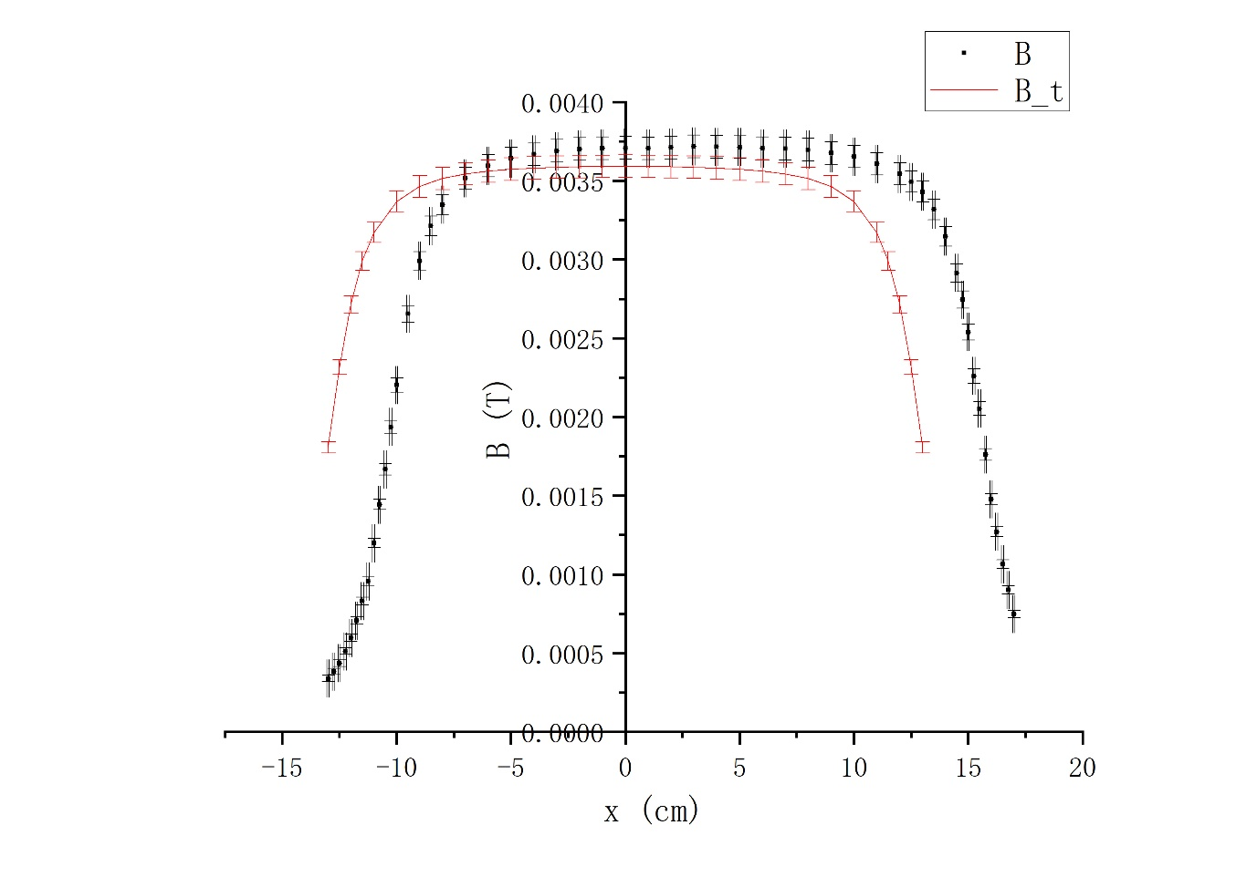

Figure 9. The theoretical and experimental *B* vs. *x*

From this figure, we know that the magnetic field usually is its largest at the center of the solenoid while becomes smaller at the end of the solenoid. Generally, the trend of the experimental one and theoretical one are similar. But there are still some differences. For example, the experimental one shifted to the right compared with the theoretical one. We may think that the actual center of the solenoid is not at 13.0 cm but around 16.0 cm according to the data we have, and we can repeat the experiment for many times to get the position. Besides, during the experiment, we find that the readings on the meter are not stable, this may be because of the precision of the device.

1. **Conclusion [1]**
   1. **Relation between sensitivity and working voltage**

In this part, we first calculate the magnetic field for

Then, for , we calculate

with relative uncertainty as . Although it is larger than 5%, we may still think this part is relatively successful because it is still within 10%. The reasons may be the precision of the device. For example, the unit of is [A] when we adjust it on the device, while the unity required is [mA], which will increase error. If we can use better device, the result will be better. Besides, we only measure the data for once. If we measure more times, it will be better.

For varying , we first calculate , and then plot the curve for vs. . In this figure, we can find that it tends to decline. Theoretically, should be proportional to , which means the graph we get should be like a horizontal line. The reasons for this may be due to the internal resistance of the wire or the precision of the device. But generally speaking, it still maintains in some range, which can prove that should be proportional to

* 1. **Relation between output voltage and magnetic field**

In this part, we first calculate magnetic field, the plot the relation of *U* vs. *B* with Origin.

Form the figure, we know that *U* and *B* are linearly dependent since and Pearson’s r = 0.99973, which are close to 1. And , where and .

Therefore, we can get that

Theoretically, , and the value we get in the previous part is . So, we can calculate the relative error respectively as

We can see that the relative error is small, so we may assume that this part is quite successful.

* 1. **Magnetic field distribution inside the solenoid**

In this part, we first calculate magnetic field of experimental and theoretical one. Then we plot *B* vs. *x*. From the figure, we know that the magnetic field usually is its largest at the center of the solenoid while becomes smaller at the end of the solenoid. Generally, the trend of the experimental one and theoretical one are similar. But there are still some differences. For example, the experimental one shifted to the right compared with the theoretical one. We may think that the actual center of the solenoid is not at 13.0 cm but around 16.0 cm according to the data we have, and we can repeat the experiment for many times to get the position. Besides, during the experiment, we find that the readings on the meter are not stable, this may be because of the precision of the device.

1. **References**

[1] Exercise 2 - lab manual [rev 3.9], UM-JI SJTU. Edited by Qin Tian, Wang Zhiyu, Lin Yiqiao, Bao Yufan, Mateusz Krzyzosiak.

[2] Uncertainty analysis handbook, UM-JI SJTU.

1. **Uncertainty analysis [2]**

**A.1. Uncertainty for relation between sensitivity and working voltage**

Since and are theoretical value, we can assume that and . For , according to the precision or uncertainty of the device, we can calculate its uncertainty as follows

Then, according to the , we can calculate the uncertainty for *B* as

**A.1.1. Data for and with**

Then, according to the , we can calculate the uncertainty for as

For and , according to the precision or uncertainty of the device, we can calculate as follows

Then, we can get as

**A.1.1. Data for and with different**

Using the first measurement as an example. For , and , according to the precision or uncertainty of the device, we can calculate as follows

According to the , we can calculate the uncertainty for as

According to the equation that , we can calculate the uncertainty as

The table below (Table 11) lists the uncertainty calculated for rest data.

|  |  |  |  |  |  |  |  |  |  |  |
| --- | --- | --- | --- | --- | --- | --- | --- | --- | --- | --- |
|  | [V] | [V] | [V] | [V] | [V] | [V] | [V/T] | [V/T] | [] | [] |
| 1 | 2.80 | 0.014 | 1.3970 | 0.0013 | 1.4677 | 0.0013 | 19.7 | 0.7 | 7.0 | 0.2 |
| 2 | 3.20 | 0.016 | 1.5983 | 0.0014 | 1.6796 | 0.0014 | 22.6 | 0.7 | 7.1 | 0.2 |
| 3 | 3.60 | 0.018 | 1.8050 | 0.0015 | 1.8964 | 0.0015 | 25.4 | 0.8 | 7.1 | 0.2 |
| 4 | 4.00 | 0.02 | 2.0053 | 0.0016 | 2.1061 | 0.0017 | 28.1 | 0.9 | 7.0 | 0.2 |
| 5 | 4.40 | 0.02 | 2.2103 | 0.0017 | 2.317 | 0.007 | 30 | 2 | 6.8 | 0.5 |
| 6 | 4.80 | 0.02 | 2.410 | 0.007 | 2.525 | 0.007 | 32 | 3 | 6.7 | 0.6 |
| 7 | 5.20 | 0.03 | 2.614 | 0.007 | 2.738 | 0.007 | 35 | 3 | 6.6 | 0.6 |
| 8 | 5.60 | 0.03 | 2.815 | 0.007 | 2.942 | 0.007 | 35 | 3 | 6.3 | 0.5 |
| 9 | 6.00 | 0.03 | 3.013 | 0.008 | 3.148 | 0.008 | 38 | 3 | 6.3 | 0.5 |
| 10 | 6.40 | 0.03 | 3.213 | 0.008 | 3.350 | 0.008 | 38 | 3 | 6.0 | 0.5 |
| 11 | 6.80 | 0.03 | 3.406 | 0.008 | 3.546 | 0.008 | 39 | 3 | 5.7 | 0.5 |
| 12 | 7.20 | 0.04 | 3.601 | 0.008 | 3.745 | 0.008 | 40 | 3 | 5.6 | 0.4 |
| 13 | 7.60 | 0.04 | 3.791 | 0.008 | 3.936 | 0.008 | 40 | 3 | 5.3 | 0.4 |
| 14 | 8.00 | 0.04 | 3.980 | 0.008 | 4.127 | 0.008 | 41 | 3 | 5.1 | 0.4 |
| 15 | 8.40 | 0.04 | 4.167 | 0.008 | 4.312 | 0.008 | 40 | 3 | 4.8 | 0.4 |
| 16 | 8.80 | 0.04 | 4.355 | 0.008 | 4.501 | 0.008 | 41 | 3 | 4.6 | 0.4 |
| 17 | 9.40 | 0.05 | 4.632 | 0.008 | 4.784 | 0.008 | 42 | 3 | 4.5 | 0.4 |
| 18 | 10.00 | 0.05 | 4.915 | 0.008 | 5.066 | 0.009 | 42 | 3 | 4.2 | 0.3 |

Table 11. Calculated uncertainty for , , , and

**A.2. Uncertainty for relation between output voltage and magnetic field**

Using the second measurement as an example, we can calculate the uncertainty for and as follows

Since and are theoretical value, we can assume that and . According to the equation that , we can calculate the uncertainty for as follows

The table below (Table 12) lists the uncertainty calculated for rest data.

|  |  |  |  |  |  |  |
| --- | --- | --- | --- | --- | --- | --- |
|  |  |  |  |  |  |  |
| 1 | 0 | 0 | 0.00000 | 0.0006 | 0 | 0 |
| 2 | 0.050 | 0.0010 | 0.02735 | 0.0006 | 0.000718 | 0.000014 |
| 3 | 0.100 | 0.002 | 0.04986 | 0.0006 | 0.00144 | 0.00003 |
| 4 | 0.150 | 0.003 | 0.07321 | 0.0006 | 0.00215 | 0.00004 |
| 5 | 0.200 | 0.004 | 0.09844 | 0.0006 | 0.00287 | 0.00006 |
| 6 | 0.250 | 0.005 | 0.11966 | 0.0007 | 0.00359 | 0.00007 |
| 7 | 0.300 | 0.006 | 0.14382 | 0.0007 | 0.00431 | 0.00009 |
| 8 | 0.350 | 0.007 | 0.16528 | 0.0007 | 0.00503 | 0.00010 |
| 9 | 0.400 | 0.008 | 0.18652 | 0.0007 | 0.00575 | 0.00011 |
| 10 | 0.450 | 0.009 | 0.20982 | 0.0007 | 0.00646 | 0.00013 |
| 11 | 0.500 | 0.010 | 0.2334 | 0.0007 | 0.00718 | 0.00014 |

Table 12. Calculated uncertainty for , and

**A.3. Uncertainty for magnetic field distribution inside the solenoid**

From the previous part, we know that . Using the first measurement as an example, we can calculate that

Since , we can calculate that

The table below (Table 13) lists the uncertainty calculated for rest data.

|  |  |  |  |  |  |  |
| --- | --- | --- | --- | --- | --- | --- |
|  | *x* [cm] | [cm] |  | [V] | *B* [T] | [T] |
| 1 | 0.00 | 0.05 | 0.01091 | 0.0006 | 0.00034 | 0.00002 |
| 2 | 0.50 | 0.05 | 0.01404 | 0.0006 | 0.00044 | 0.00002 |
| 3 | 1.00 | 0.05 | 0.01927 | 0.0006 | 0.00060 | 0.00002 |
| 4 | 1.50 | 0.05 | 0.02675 | 0.0006 | 0.00083 | 0.00002 |
| 5 | 2.00 | 0.05 | 0.03860 | 0.0006 | 0.00120 | 0.00003 |
| 6 | 2.50 | 0.05 | 0.05368 | 0.0006 | 0.00167 | 0.00004 |
| 7 | 3.00 | 0.05 | 0.07097 | 0.0006 | 0.00220 | 0.00005 |
| 8 | 3.50 | 0.05 | 0.08549 | 0.0006 | 0.00265 | 0.00005 |
| 9 | 4.00 | 0.05 | 0.09632 | 0.0006 | 0.00299 | 0.00006 |
| 10 | 4.50 | 0.05 | 0.10343 | 0.0007 | 0.00321 | 0.00006 |
| 11 | 5.00 | 0.05 | 0.10781 | 0.0007 | 0.00335 | 0.00007 |
| 12 | 0.25 | 0.05 | 0.01233 | 0.0006 | 0.00038 | 0.00002 |
| 13 | 0.75 | 0.05 | 0.01649 | 0.0006 | 0.00051 | 0.00002 |
| 14 | 1.25 | 0.05 | 0.02274 | 0.0006 | 0.00071 | 0.00002 |
| 15 | 1.75 | 0.05 | 0.03081 | 0.0006 | 0.00096 | 0.00003 |
| 16 | 6.00 | 0.05 | 0.11323 | 0.0007 | 0.00352 | 0.00007 |
| 17 | 7.00 | 0.05 | 0.11577 | 0.0007 | 0.00360 | 0.00007 |
| 18 | 8.00 | 0.05 | 0.11729 | 0.0007 | 0.00364 | 0.00007 |
| 19 | 9.00 | 0.05 | 0.11812 | 0.0007 | 0.00367 | 0.00007 |
| 20 | 10.00 | 0.05 | 0.11880 | 0.0007 | 0.00369 | 0.00007 |
| 21 | 11.00 | 0.05 | 0.11918 | 0.0007 | 0.00370 | 0.00007 |
| 22 | 12.00 | 0.05 | 0.11931 | 0.0007 | 0.00371 | 0.00007 |
| 23 | 13.00 | 0.05 | 0.11943 | 0.0007 | 0.00371 | 0.00007 |
| 24 | 14.00 | 0.05 | 0.11930 | 0.0007 | 0.00370 | 0.00007 |
| 25 | 15.00 | 0.05 | 0.11950 | 0.0007 | 0.00371 | 0.00007 |
| 26 | 16.00 | 0.05 | 0.11971 | 0.0007 | 0.00372 | 0.00007 |
| 27 | 17.00 | 0.05 | 0.11962 | 0.0007 | 0.00371 | 0.00007 |
| 28 | 18.00 | 0.05 | 0.11959 | 0.0007 | 0.00371 | 0.00007 |
| 29 | 19.00 | 0.05 | 0.11931 | 0.0007 | 0.00371 | 0.00007 |
| 30 | 20.00 | 0.05 | 0.11929 | 0.0007 | 0.00370 | 0.00007 |
| 31 | 21.00 | 0.05 | 0.11905 | 0.0007 | 0.00370 | 0.00007 |
| 32 | 22.00 | 0.05 | 0.11836 | 0.0007 | 0.00368 | 0.00007 |
| 33 | 23.00 | 0.05 | 0.11763 | 0.0007 | 0.00365 | 0.00007 |
| 34 | 24.00 | 0.05 | 0.11615 | 0.0007 | 0.00361 | 0.00007 |
| 35 | 25.00 | 0.05 | 0.11410 | 0.0007 | 0.00354 | 0.00007 |
| 36 | 25.50 | 0.05 | 0.11251 | 0.0007 | 0.00349 | 0.00007 |
| 37 | 26.00 | 0.05 | 0.11044 | 0.0007 | 0.00343 | 0.00007 |
| 38 | 26.50 | 0.05 | 0.10680 | 0.0007 | 0.00332 | 0.00007 |
| 39 | 27.00 | 0.05 | 0.10131 | 0.0007 | 0.00315 | 0.00006 |
| 40 | 27.50 | 0.05 | 0.09387 | 0.0006 | 0.00292 | 0.00006 |
| 41 | 27.75 | 0.05 | 0.08843 | 0.0006 | 0.00275 | 0.00005 |
| 42 | 28.00 | 0.05 | 0.08180 | 0.0006 | 0.00254 | 0.00005 |
| 43 | 28.25 | 0.05 | 0.07280 | 0.0006 | 0.00226 | 0.00005 |
| 44 | 28.50 | 0.05 | 0.06613 | 0.0006 | 0.00205 | 0.00004 |
| 45 | 28.75 | 0.05 | 0.05673 | 0.0006 | 0.00176 | 0.00004 |
| 46 | 29.00 | 0.05 | 0.04758 | 0.0006 | 0.00148 | 0.00003 |
| 47 | 29.25 | 0.05 | 0.04091 | 0.0006 | 0.00127 | 0.00003 |
| 48 | 29.50 | 0.05 | 0.03429 | 0.0006 | 0.00106 | 0.00003 |
| 49 | 29.75 | 0.05 | 0.02903 | 0.0006 | 0.00090 | 0.00003 |
| 50 | 30.00 | 0.05 | 0.02411 | 0.0006 | 0.00075 | 0.00002 |
| 51 | 2.25 | 0.05 | 0.04649 | 0.0006 | 0.00144 | 0.00003 |
| 52 | 2.75 | 0.05 | 0.06237 | 0.0006 | 0.00194 | 0.00004 |

Table 13. Calculated uncertainty for , and

Since and are theoretical value, we can assume that and . For , according to the precision or uncertainty of the device, we can calculate its uncertainty as follows

Then, according to the , we can calculate the uncertainty for *B* as

The whole table is listed below (Table 14)

|  |  |  |  |
| --- | --- | --- | --- |
| *x* [cm] | [mT] | *B* [T] | [T] |
| 0.0 | 0.7233 | 0.00181 | 0.00004 |
| 0.5 | 0.9261 | 0.00232 | 0.00005 |
| 1.0 | 1.0863 | 0.00272 | 0.00005 |
| 1.5 | 1.1963 | 0.00299 | 0.00006 |
| 2.0 | 1.2685 | 0.00317 | 0.00006 |
| 3.0 | 1.3478 | 0.00337 | 0.00007 |
| 4.0 | 1.3856 | 0.00346 | 0.00007 |
| 5.0 | 1.4057 | 0.00351 | 0.00007 |
| 6.0 | 1.4173 | 0.00354 | 0.00007 |
| 7.0 | 1.4245 | 0.00356 | 0.00007 |
| 8.0 | 1.4292 | 0.00357 | 0.00007 |
| 9.0 | 1.4323 | 0.00358 | 0.00007 |
| 10.0 | 1.4343 | 0.00359 | 0.00007 |
| 11.0 | 1.4356 | 0.00359 | 0.00007 |
| 12.0 | 1.4363 | 0.00359 | 0.00007 |
| 13.0 | 1.4366 | 0.00359 | 0.00007 |
| 14.0 | 1.4363 | 0.00359 | 0.00007 |
| 15.0 | 1.4356 | 0.00359 | 0.00007 |
| 16.0 | 1.4343 | 0.00359 | 0.00007 |
| 17.0 | 1.4323 | 0.00358 | 0.00007 |
| 18.0 | 1.4292 | 0.00357 | 0.00007 |
| 19.0 | 1.4245 | 0.00356 | 0.00007 |
| 20.0 | 1.4173 | 0.00354 | 0.00007 |
| 21.0 | 1.4057 | 0.00351 | 0.00007 |
| 22.0 | 1.3856 | 0.00346 | 0.00007 |
| 23.0 | 1.3478 | 0.00337 | 0.00007 |
| 24.0 | 1.2685 | 0.00317 | 0.00006 |
| 24.5 | 1.1963 | 0.00299 | 0.00006 |
| 25.0 | 1.0863 | 0.00272 | 0.00005 |
| 25.5 | 0.9261 | 0.00232 | 0.00005 |
| 26.0 | 0.7233 | 0.00181 | 0.00004 |

Table 14. Calculated uncertainty for